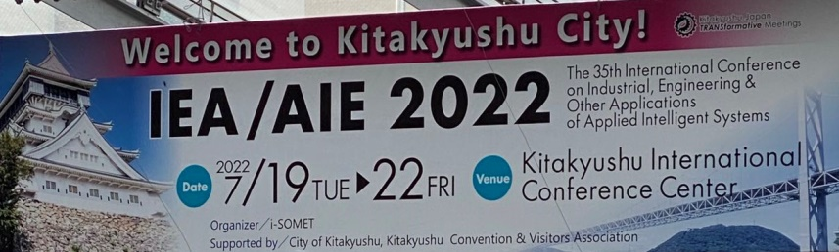
Advances in Artificial Intelligence: Theory and Practice
Hamido Fujita¹, Philippe Fournier-Viger², Moonis Ali³, Yinlin Wang⁴
¹Iwate Prefectural University, Morioka, Japan
ORCID: 0000-0001-5256-210X
²Shenzhen University, Shenzhen, China
ORCID: 0000-0002-7680-9899
³Texas State University, San Marcos, Texas, USA
⁴Shanghai University of Finance and Economics, China
Overview
The 35th edition of the IEA/AIE2022 (International Conference on Industrial, Engineering, and Other Applications of Applied Intelligent Systems) was hosted in hybrid mode from July 19th to July 22nd 2022 in Kitakyushu, Japan. IEA/AIE is an annual conference dedicated to advances related to the theory and applications of artificial intelligence that started in 1988, and has been hosted in over twenty countries. IEA/AIE 2022 was organized in cooperation with the ACM Special Interest Group on Artificial Intelligence (SIGAI) and has received the support of Springer, the International Society of Applied Intelligence (ISAI), Kitakyushu city, Universiti Teknologi Malaysia, i-SOMET Inc., and others.

The conference had a main track and five special sessions for emerging topics in applied intelligence, named Spatiotemporal Big Data Analytics (SBDA 2022), Intelligent Systems and e-Applications (ISeA 2022), Collective Intelligence in Social Media (CISM 2022), Multi-Agent Systems and Metaheuristics for Complex Problems (MASMCP 2022), and Intelligent Knowledge Engineering in Decision Making Systems (IKEDS 2022). All the submissions were peer-reviewed by at least three reviewers following a double-blind process. The Program Committee was composed of 74 researchers from 23 countries. The evaluation led to the acceptance of 67 full papers and 14 short papers from a total of 127 submissions published as book as part of the Lecture Notes in Computer Science book series (LNAI,volume 13343) in title Advances and Trends in Artificial Intelligence. Theory and Practices in Artificial Intelligence: https://link.springer.com/book/10.1007/978-3-031-08530-7. This book can be accessed free (till October 4, 2022) form the conference web site: https://ieaaie2022.wordpress.com/proceedings/. Moreover, the selected best papers of the those presented are to be evaluated and later be invited for a dedicated special issue on IEA/AIE 2022, to appear in the Applied Intelligence journal.

The IEA/AIE2022 conference proceedings covers a wide relevant research and practices in Artificial Intelligence topics, some theoretical and others applied to solve real-life problems from multiple domains. This include industrial applications, health informatics, optimization, video and image processing, natural language processing, pattern recognition, clustering and classification, security applications, modeling, transportation and urban applications, social networks, robotic, games, consumer applications, and games. All papers were presented in hybrid mode (either online or offline) due to the COVID-19 pandemic. In this year 2022 round, we have good participants from Germany, Spain and Romania, in addition to participants from Japan as shown in the photo of banquet gathering in Kitakyushu.
The Banquet event at the IEA/AIE2022.

Keynote Presentations
Two distinguished researchers were invited to give keynote talks (cf. Fig. 1).

In the talk “Improving Predictive Maintenance with Advanced Machine Learning “, provided by Prof. Sebastian Ventura, from the University of Cordoba (Spain), the speaker described the role that machine learning and big data mining algorithms can play in developing predictive maintenance strategies for manufacturing and other industrial applications. He presented a recent project as example, and discussed opportunities and challenges.

In “Build a Health Chain and Promote the Construction of an Active Health Service System “, Prof. Tao Wu from the Shanghai University of Medicine and Health Sciences (China) described the urgent need to use artificial intelligence, blockchain the Internet of Things and other cutting-edge technologies to build an integrated healthcare chain to improve the care of elderly people. Several innovative applications were described.

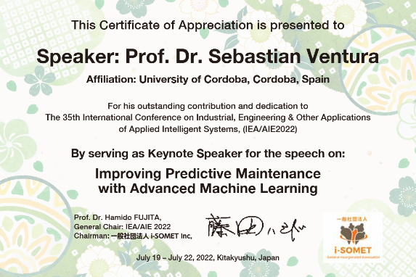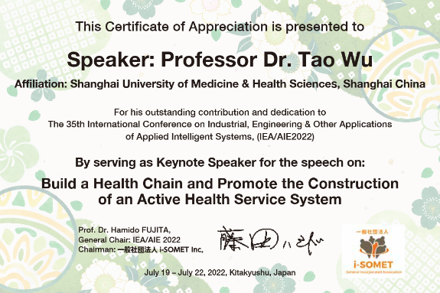
Fig.1 Recognition for the Keynote Speakers
Best Paper Awards
Based on the evaluation of papers, a special committee analyzed the scores and content of the top 15 papers. And the selection criterial concluded the awards as below:
Best Student Paper award category which is supported by ACM SIGAI represented as a support from ACM SIGAI in registration fee payment on behalf of the student: The paper is: Question Difficulty Estimation with Directional Modality Association in Video Question Answering, by the authors: Bong-Min Kim & Seong-Bae Park, https://doi.org/10.1007/978-3-031-08530-7_24. This was part of the support and collaboration from ACM SIGAI for the IEA/AIE2022.

In addition, the evaluation committee of the conference provided other categorical based award reflected to theory, practices and presentation, as well as best session paper. These awards were sponsored by Springer and the IEA/AIE2022 conference organization. The recognition certificates for these awards are shown in Fig. 2, and as below:
- The “Best Application Paper” was awarded to “A Generalized Inverted Dirichlet Predictive Model for Activity Recognition using Small Training Data” by Jiaxun Guo and Manar Amayri and Wentao Fan and Nizar Bouguila, https://doi.org/10.1007/978-3-031-08530-7_36
- The “Best Theory Paper” award went to “Evolution of Prioritized EL Ontologies” by Rim Mohamed and Zied Loukil and Faiez Gargouri and Zied Bouraoui, https://doi.org/10.1007/978-3-031-08530-7_72
- The “Best Special Session Paper” was given to “An Oriented Attention Model for Infectious Disease Cases Prediction” by Peisong Zhang and Zhijin Wang and Guoqing Chao and Yaohui Huang and Jingwen Yan, https://doi.org/10.1007/978-3-031-08530-7_11
- The “Best Technical Presentation” award was given to “Multi-Granular Large Scale Group Decision-Making Method with a new Consensus Measure Based on Clustering of Alternatives in Modifiable Scenarios” by Jose Ramon Trillo and Ignacio Javier Perez and Enrique Herrera-Viedma and Juan Antonio Morente-Molinera and Francisco Javier Cabrerizo, https://doi.org/10.1007/978-3-031-08530-7_63

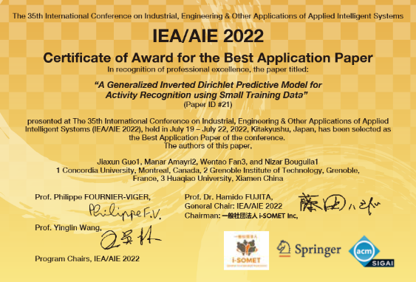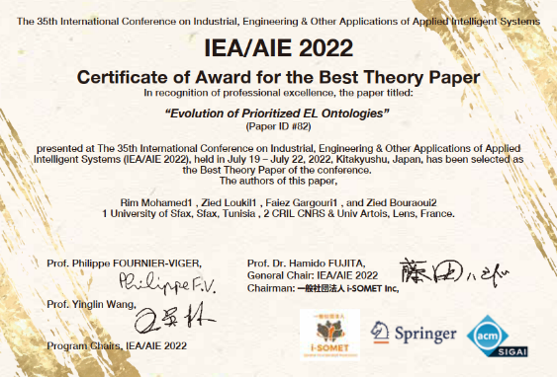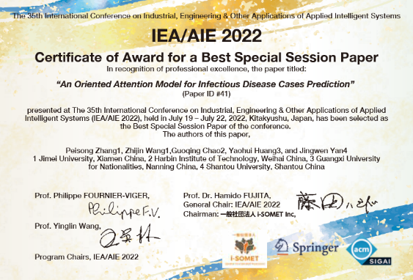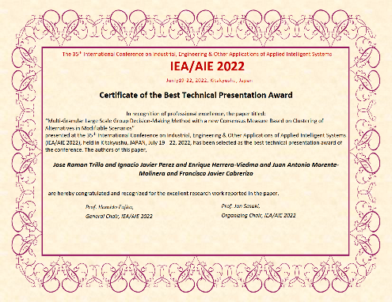
Fig. 2. Awards certificates for the Best Papers and Best Technical Presentation
The IEA/AIE 2023 Conference
The 36th edition of the IEA/AIE conference will be held from July 19th to July 22nd 2023, in Shanghai, China. Details about the conference can be found at: http://ieaaie2023.com/ . Continuing the tradition of IEA/AIE, submissions are invited on all topics related to applied intelligence and also theoretical contributions. This covers various emerging domains and innovative fields such as sensor networks, smart healthcare, drone navigation, robotics, intelligent manufacturing, and the Internet of Things.

Hamido Fujita is a professor of computer science at Iwate Prefectural University, Japan
Philippe Fournier-Viger is distinguished professor of computer science at the Shenzhen University, China
Moonis Ali is a professor of computer science at Texas State University, USA
Yinlin Wang is a professor of computer science at the Shanghai University of Finance and Economics, China

